**SRI SHANMUGHA COLLEGE OF ENGINEERING AND TECHNOLOGY**

**Department of Biomedical Engineering**

**SMART PARKING**

**Phase 5 Submission Document**

**Team members**

S. Swetha- (732721121055)

M. Sindhu - (732721121046)  
 T. Srimathi- (732721121051)  
 C. Chanthruba- (732721121007)

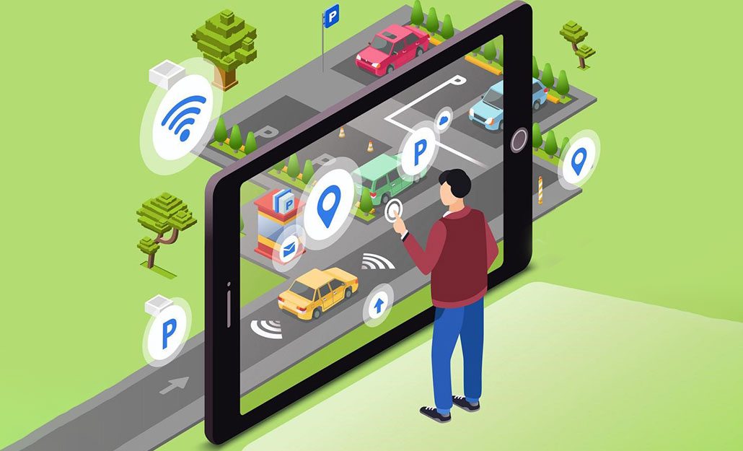 R. Bharathi- (732721121006)

**Introduction:**

A Smart Parking System is an integrated technology solution designed to optimize and streamline the management and utilization of parking spaces within a parking facility or on the streets. It leverages various sensors, cameras, and data processing techniques to provide real-time information to drivers and parking facility operators.

The goal of parking system project is to reserve parking spot for a car/vehicle before it arrives. One of the most problems that the driver faces is finding a free parking spot, so many driver stopping their cars at the edges of the street. Therefore, we choose this to prevent the frustration of finding a parking spot and they can reserve a spot when they stay at home. It is an IOT based project.

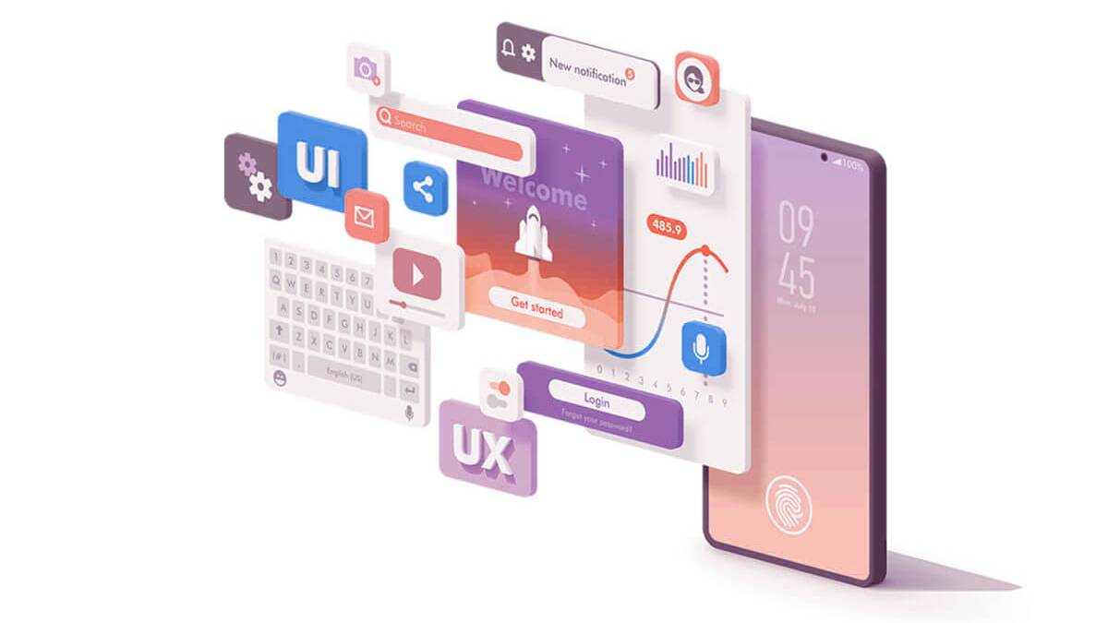

**Problem statement:**

One of the most problems that the driver faces is finding a free parking spot. It encompasses various challenges, such as congestion in urban areas, inefficient use of parking spaces, and the need for a seamless and convenient parking solution. In urban and suburban areas, the existing traditional parking systems are plagued by inefficiency, congestion, and a lack of user convenience. It leads to traffic, environmental impact, wastage of stress and time, economic losses, high fuel consumption, etc.

**Innovation:**

To overcome the above given statement we proposed an IOT based application for Smart parking systems, users may access information about available parking spaces, reserve spots and make payments through a custom IOT application provided by the parking facility or the parking services. We choose this to prevent the frustration of finding a parking spot and they can reserve a spot when they stay at home. Sensor-based technology is used to monitor parking spaces in real-time. Drivers can access information through mobile apps or electronic signage to find available parking spots, reducing the time spent searching for a space.

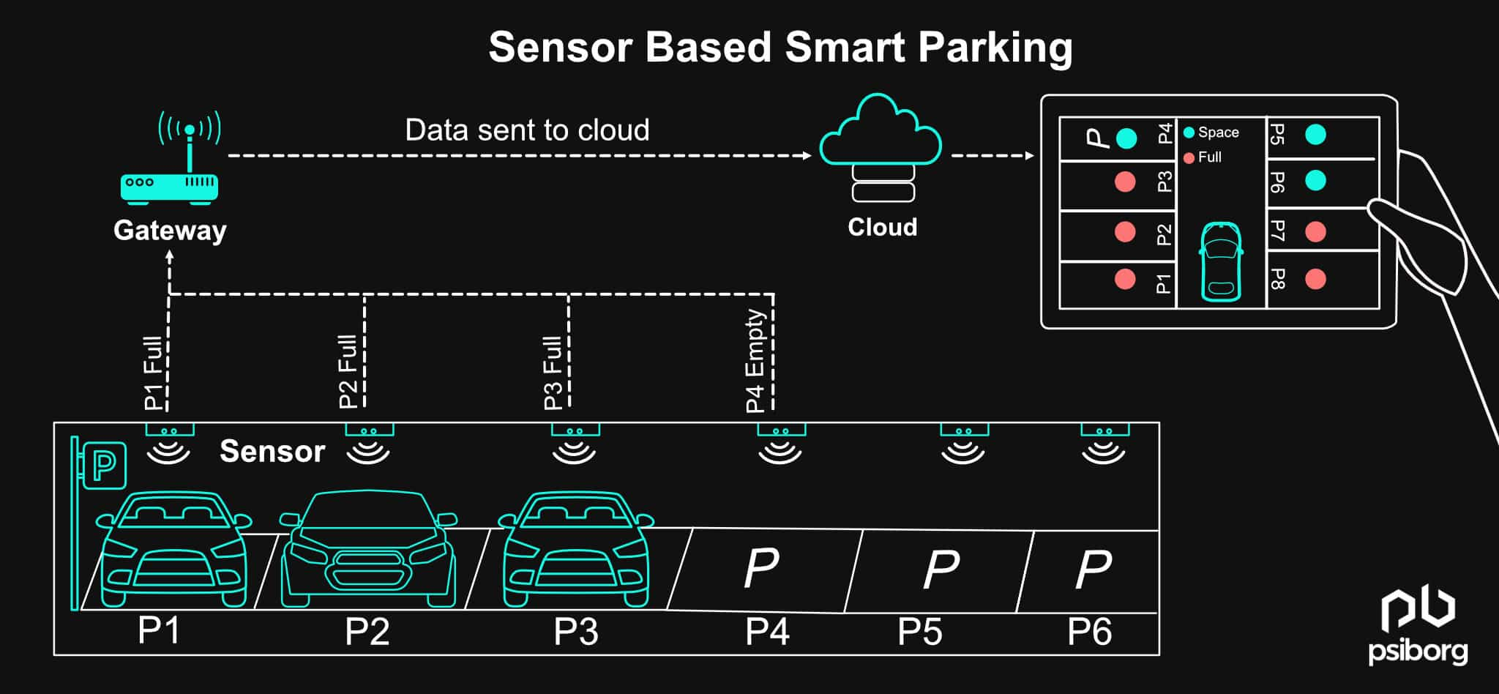

**Overview of the process:**

Smart parking systems aim to improve the efficiency and convenience of parking by leveraging technology and data to assist drivers in finding available parking spaces. The process of a typical smart parking system involves several key components and steps:

**Sensor Deployment**: Sensors, such as ultrasonic sensors, infrared sensors, or cameras, are installed in parking spaces or areas to monitor their occupancy status. These sensors can detect whether a parking spot is vacant or occupied.

**Data Collection:** The deployed sensors continuously collect data on the availability of parking spaces. This data is sent to a central server or cloud-based platform for processing and analysis.

**Data Processing and Analysis**: The data collected from sensors is processed and analyzed in real-time to determine the availability of parking spaces. Machine learning algorithms may be used to predict parking spot availability based on historical data and real-time sensor readings.

**User Interface:** A user-friendly interface, often in the form of a mobile app or a website, is made available to drivers. This interface provides real-time information about parking availability, including the number of available spots and their locations.

**Navigation and Booking:** Drivers can use the app or website to search for available parking spots near their destination. The system provides navigation instructions to guide drivers to the selected parking spot. Some systems also allow users to reserve parking spaces in advance.

**Payment and Billing:** Payment for parking can be integrated into the app or website. Drivers can make payments electronically, reducing the need for physical tickets or cash. Parking fees can be automatically calculated based on the duration of the stay.

**Feedback and Alerts:** The system can provide alerts to drivers, such as reminders of when their parking time is about to expire. Drivers can also provide feedback on the parking experience, helping operators improve the system.

**Management and Analytics:** Operators of the smart parking system have access to a management dashboard where they can monitor the status of parking spaces, gather analytics, and make data-driven decisions to optimize parking operations.

**Integration:** Smart parking systems can be integrated with other urban infrastructure systems, such as traffic management and public transportation, to create a more holistic approach to urban mobility.

**Requirements:**

* Raspberry Pi
* Ultrasonic sensor
* IR Sensors
* Jumpers
* RFID Reader (Radio frequency identification)
* ESP8266 Serial Wi-Fi module
* Red, Green, Blue LED’s
* Proteus software
* Mobile application

**Model diagram:**

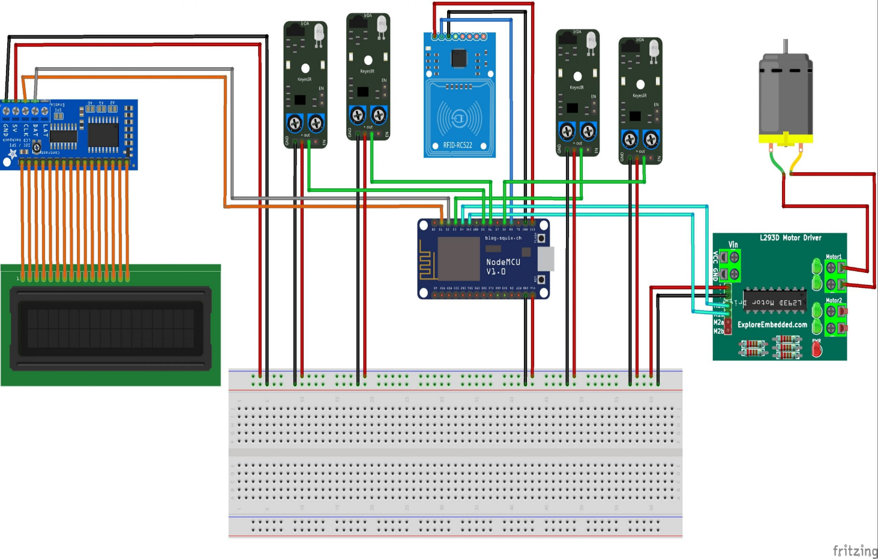Creating a smart parking system using a Raspberry Pi involves combining hardware components, such as sensors and cameras, with software to monitor and manage parking spaces efficiently.

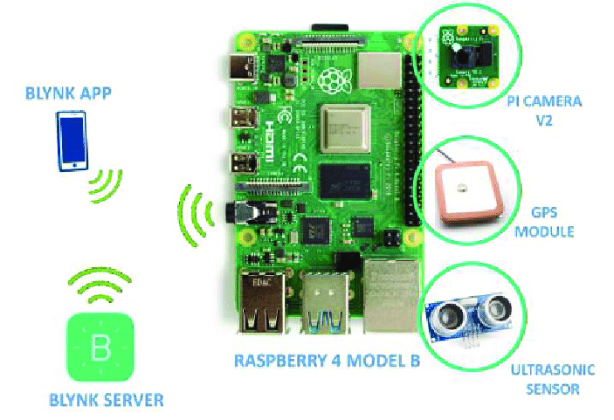

**Sensors used:**

**1)Ultrasonic Sensor:**

An ultrasonic sensor is a type of sensor that uses high-frequency sound waves (ultrasonic waves) to detect and measure the distance to objects in its vicinity. These sensors are commonly used for proximity sensing, object detection, and distance measurement in various applications.

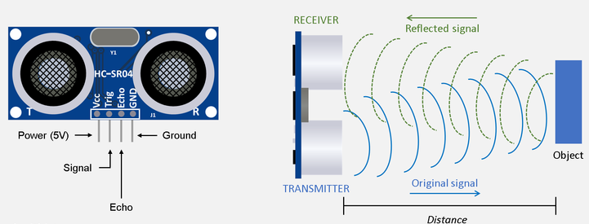 Ultrasonic sensors are commonly used in a variety of applications, including robotics, automotive parking assistance systems, industrial automation, and even in some consumer electronics.

**2)IR Sensor:**

An IR sensor, or infrared sensor, is a type of electronic device that is designed to detect and respond to infrared (IR) radiation. Infrared radiation is part of the electromagnetic spectrum and consists of wavelengths longer than those of visible light. IR sensors are used for a wide range of applications, including remote controls, motion detection, object detection, and temperature measurement.

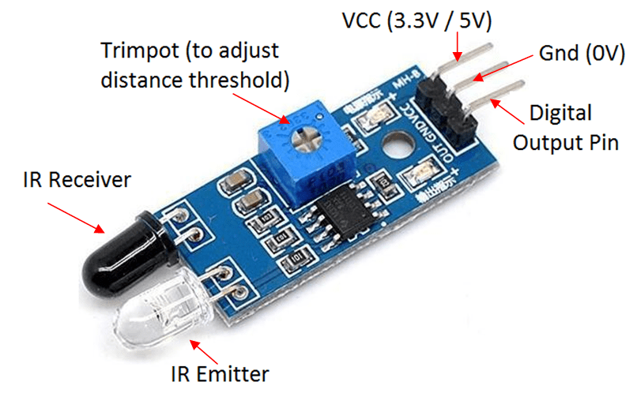

**Sensors and Raspberry pi integration:**

A Raspberry Pi is a series of small, affordable, single-board computers developed by the Raspberry Pi Foundation. These computers are designed for educational purposes, hobbyist projects, and various practical applications. Raspberry Pi boards are credit-card-sized, and they come equipped with the essential components required for basic computing, including a CPU, RAM, storage, input/output ports, and support for various operating systems.

The Raspberry Pi has had a significant impact on the world of computing and education due to its affordability and versatility, making it a popular choice for a wide range of projects and applications.

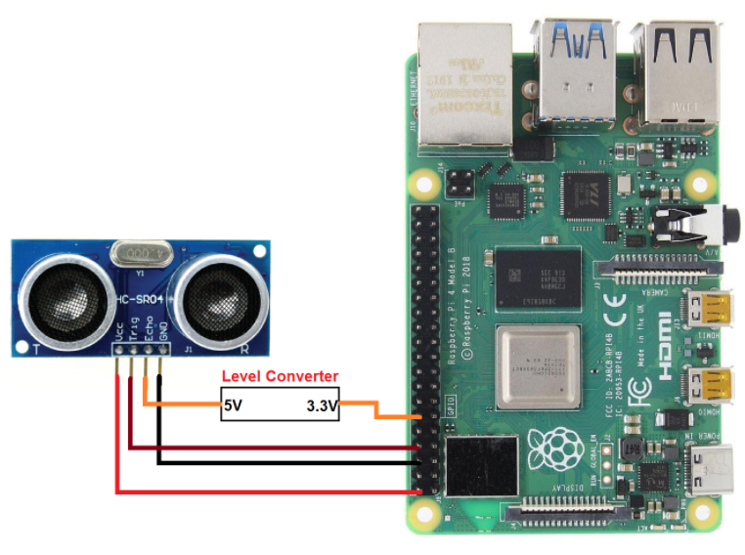**Application development:**

Developing a mobile application involves several key steps, from planning and design to coding, testing, and deployment. Here is a general overview of the mobile app development process:

**1. Define Your App Idea:** Start by clearly defining your app's purpose, target audience, and the problems it aims to solve. Consider conducting market research to understand user needs and competition.

**2. Choose a Platform**: Decide whether you want to develop the app for iOS, Android, or both (cross-platform). Each platform has its development tools and languages (Swift/Objective-C for iOS, Java/Kotlin for Android), and you may also explore cross-platform frameworks like React Native or Flutter.

**3. Plan Your App:** Create a detailed project plan that outlines the app's features, functionalities, user interface, and user experience. Consider creating wireframes and mockups to visualize your app's design.

**4. Set Up the Development Environment:** Install the necessary software development kits (SDKs), IDEs (Integrated Development Environments), and tools for your chosen platform(s).

**5. Design the User Interface (UI):** Create the app's user interface design, ensuring it is user-friendly and visually appealing. Use design tools like Adobe XD, Sketch, or Figma.

**6. Develop Your App:** Write the code for your app, implementing the features and functionalities you've planned. Follow best coding practices and guidelines for your chosen platform.

**7. Test Your App:** Conduct thorough testing of your app to identify and fix bugs, usability issues, and performance problems. Use emulators/simulators and real devices for testing.

**8. Debug and Optimize:** Debug and optimize your app's code to ensure it runs smoothly, efficiently, and without crashes. Optimize for performance and memory management.

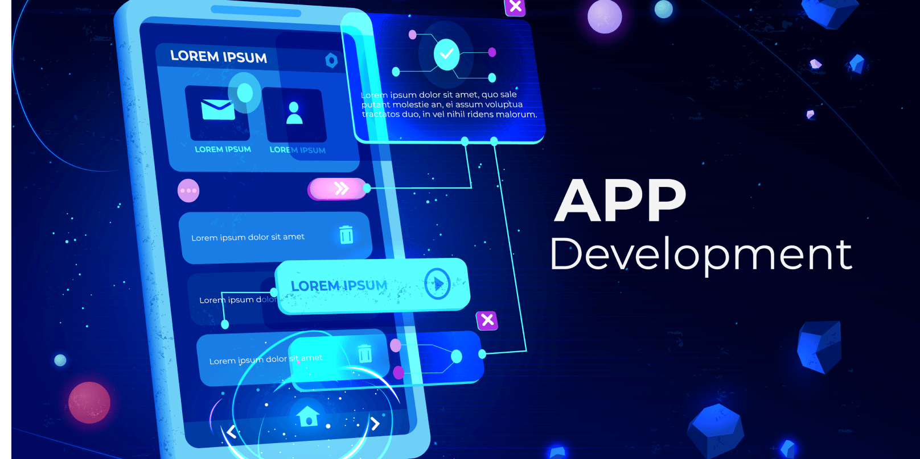**9. Implement Backend Services (if needed):** If your app requires server-side functionality (e.g., user authentication, data storage, or real-time updates), develop the necessary backend components or use cloud-based services.

**10. Add App Features:** Integrate additional features like user authentication, social sharing, geolocation, push notifications, and any APIs or third-party services your app relies on.

**11. Security and Privacy:** Implement security measures to protect user data and privacy. Secure data transmission, use encryption, and follow best practices for user authentication.

**12. Test on Real Devices:**  Test your app on various real devices to ensure compatibility and performance on a range of screen sizes and operating system versions.

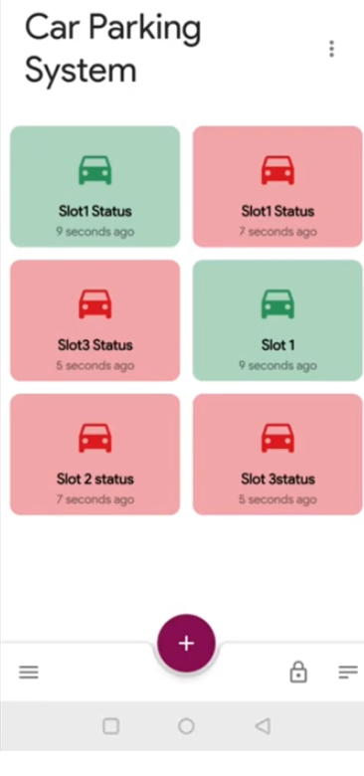

**Python scripts on Raspberry Pi:**

import RPi.GPIO as GPIO

import time

# Set GPIO pins

trigger_pin = 18

echo_pin = 17

# Set GPIO mode

GPIO.setmode(GPIO.BCM)

# Setup GPIO pins

GPIO.setup(trigger_pin, GPIO.OUT)

GPIO.setup(echo_pin, GPIO.IN)

try:

while True:

# Send a trigger pulse

GPIO.output(trigger_pin, True)

time.sleep(0.00001)

GPIO.output(trigger_pin, False)

pulse_start = time.time()

while GPIO.input(echo_pin) == 0:

pulse_start = time.time()

pulse_end = time.time()

while GPIO.input(echo_pin) == 1:

pulse_end = time.time()

pulse_duration = pulse_end - pulse_start

distance = pulse_duration * 17150 # Speed of sound = 343 m/s (17150 cm/s)

# Check if a car is present based on distance

if distance < 10: # Adjust this value based on your parking space layout

print("Parking space is occupied")

else:

print("Parking space is vacant")

time.sleep(1) # Check the status periodically

except KeyboardInterrupt:

GPIO.cleanup()

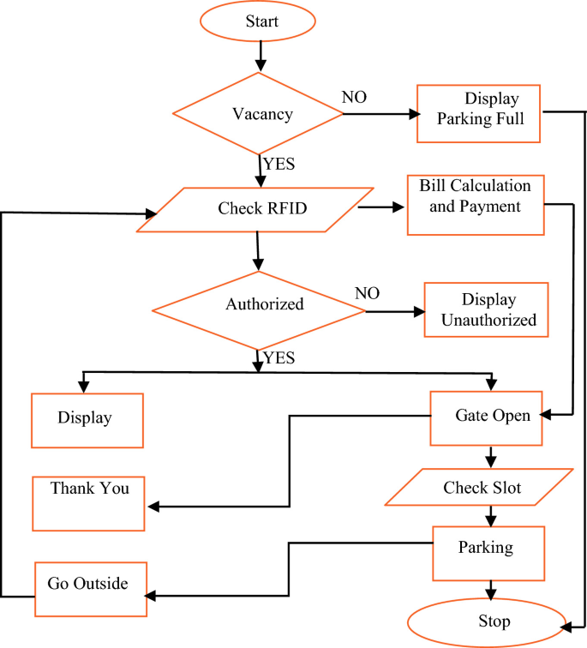**Flowchart:**

**Working:**

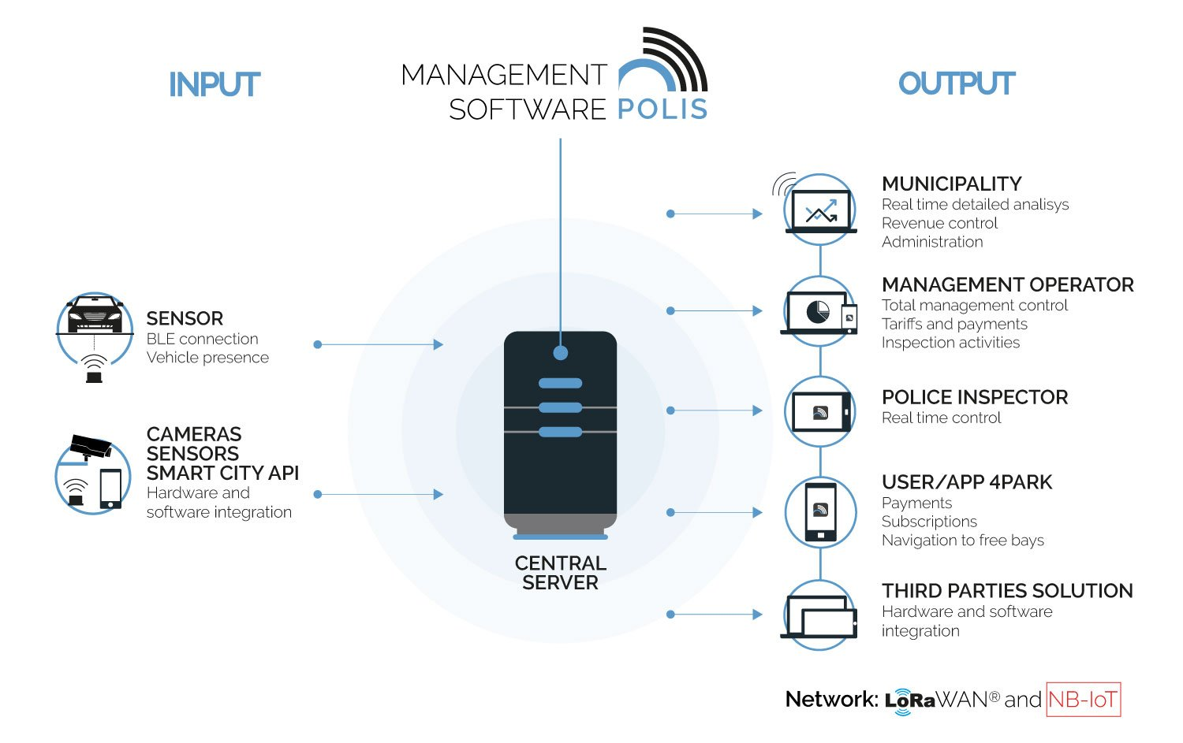



**Execution of realtime parking availability:**

The execution of a parking availability system involves several key components and processes, including data collection, analysis, user interface development, and communication. “***It is a live parking status on mobile application using Proteus Simulation Software.”***

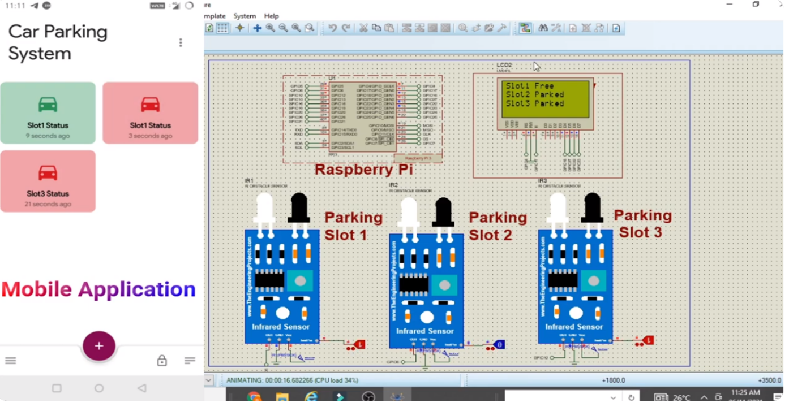

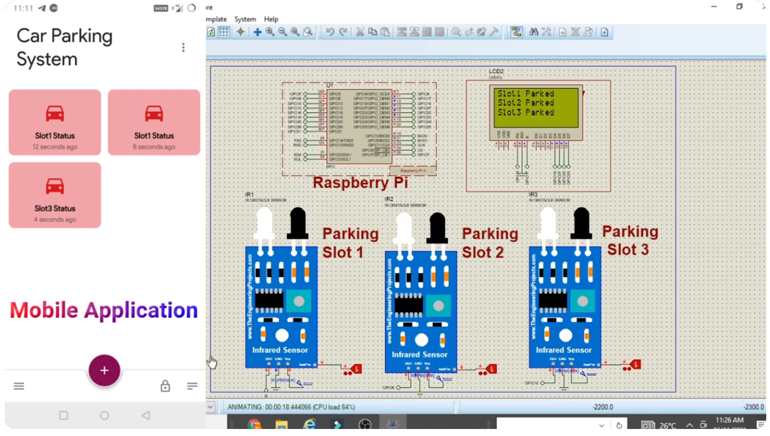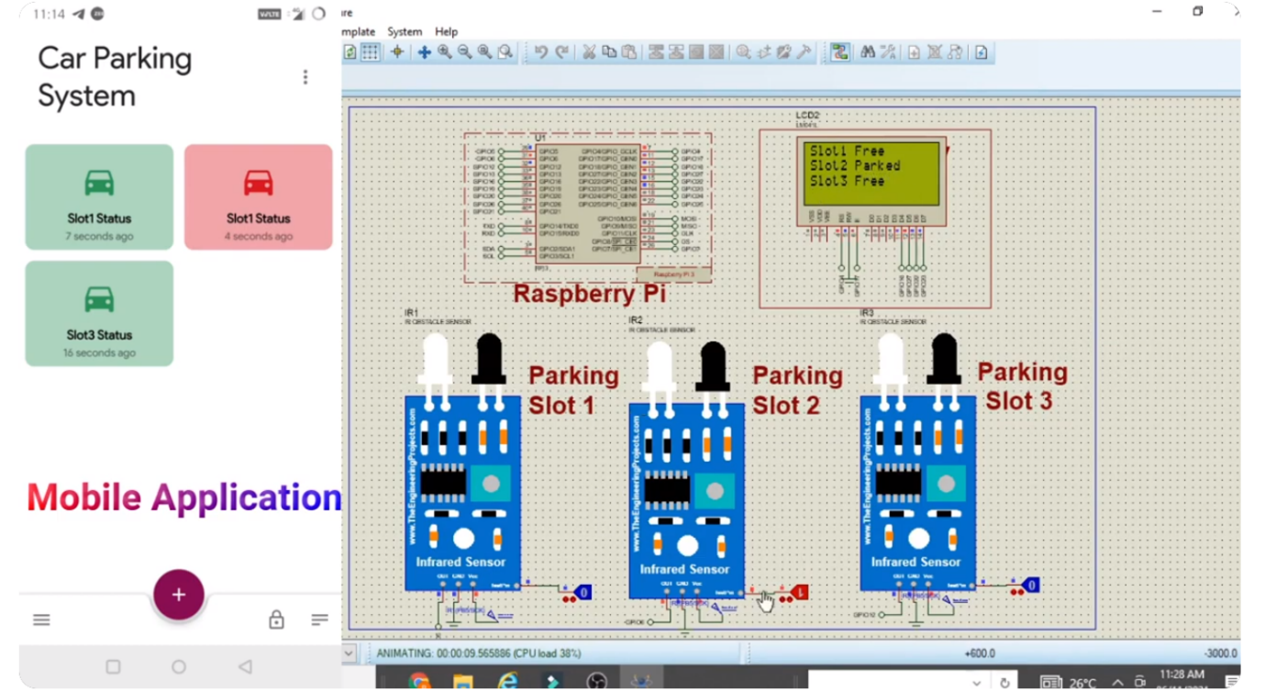

**Model training:**

**System output:**

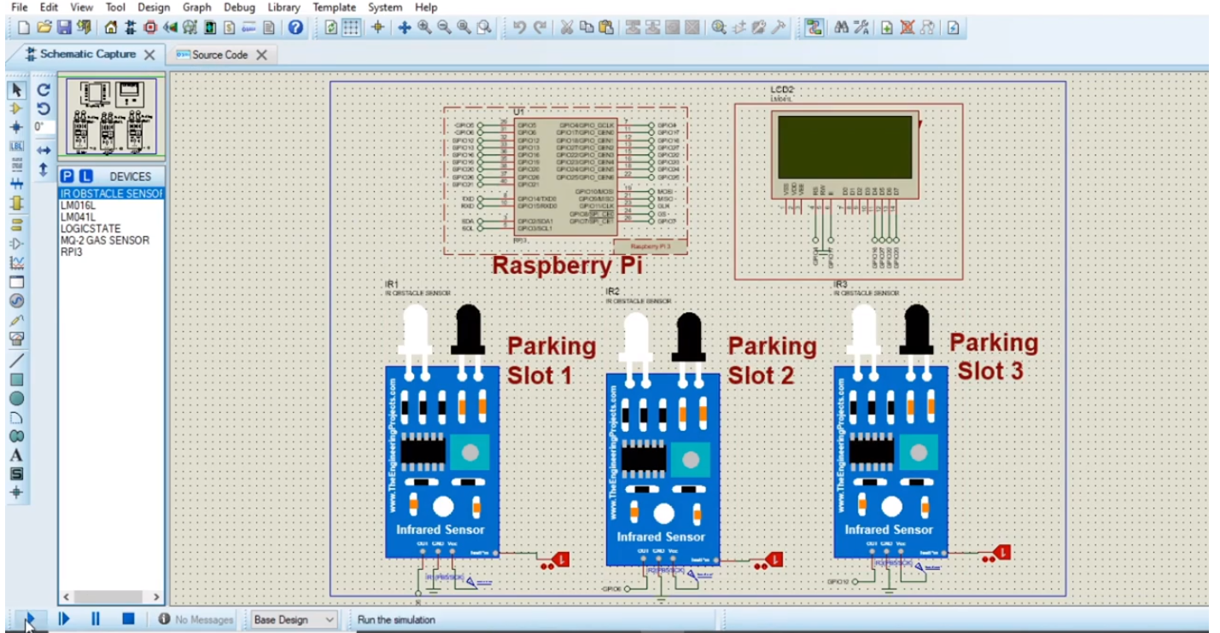**Conclusion:**

Smart parking solutions offer a comprehensive approach to tackling the challenges associated with parking in today's urban environments. While initial implementation can be an investment, the long-term benefits in terms of reduced traffic congestion, environmental impact, and improved user experiences make smart parking a valuable addition to modern cities. As technology continues to advance, smart parking systems are likely to evolve and become even more integral to urban planning and sustainability efforts.

**Future work:**

The future of the smart parking system is expected to be significantly influenced by the arrival of automated vehicles (Avs). Several cities around the world are already beginning to trial self-parking vehicles, specialized AV parking lots and robotic parking valets.